**RIGID3D ANKA**

**1/10 RC SHORT COURSE TRUCK**

**English**

**Version 1.0**

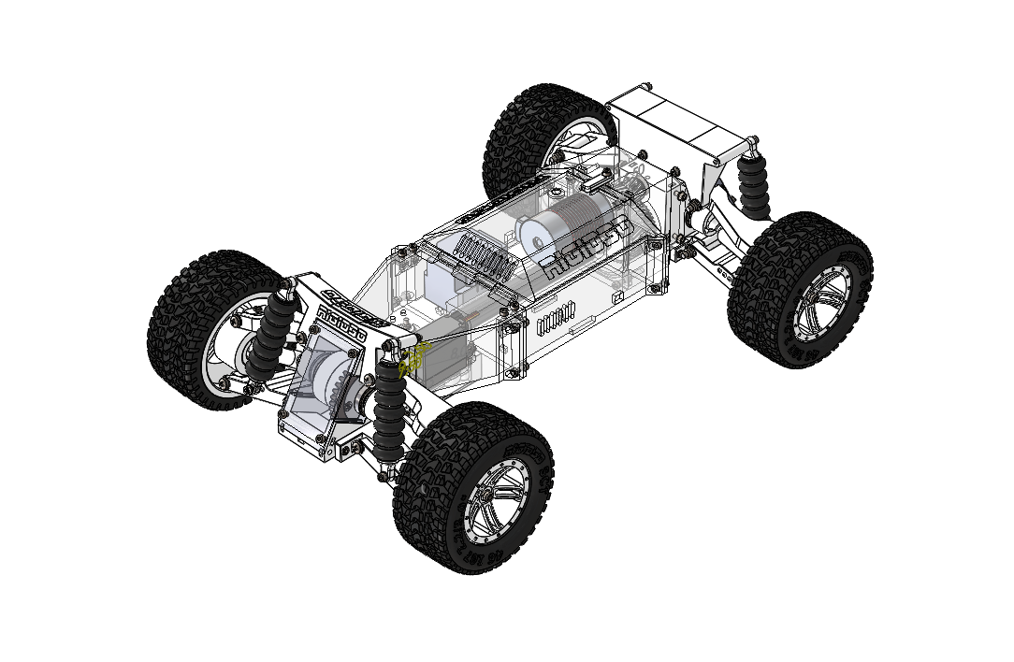

[Rigid3D Anka RC Truck](https://www.rigid3d.com/rigid3d-anka-rc-truck/)© 2022 by [Rigid3D](https://www.rigid3d.com/)is licensed under [CC BY-SA 4.0](http://creativecommons.org/licenses/by-sa/4.0/?ref=chooser-v1)

# CONTENTS

CONTENTS 2

INTRODUCTION 3

LICENSE 3

LINKS 3

SPECIFICATIONS 4

NEEDED TOOLS 5

CONSUMABLES 5

NON-PRINTED PARTS BOM 6

PRINTED PARTS BOM & PRINT SETTINGS 7

EXPLODED DRAWINGS 14

DIFFERENTIAL INNER ASSY 14

DIFFERENTIAL ASSY 15

SHOCK ASSY 16

WHEEL ASSY 17

WHEEL SHAFT ASSY 18

FRONT ASSY 19

BACK ASSY 21

GEAR BOX ASSY 23

DRIVE SHAFT ASSY 24

RIGID3D SCT BACK ASSY 25

RIGID3D SCT Front ASSY 26

RIGID3D SCT V2 28

BUMPER FRONT 29

BUMPER BACK 30

# INTRODUCTION

Anka is a mostly 3d printed 1/10 RC Short Course Truck which is inspired and remixed from the excellent Tarmo4 project. (You may reach the Tarmo4 project's details from [here](https://www.reddit.com/r/EngineeringNS/).)

If you are a terrible driver like me, this hobby might become a bit expensive. Especially bashers may encounter lots of crashes and breakage which discourages the hobbyist. I wanted to design a basher which is mostly 3d printed so that I can drive it without worrying about crashes and breaks. I enjoy bashing more since I don't have to pay for the spares and wait for them to arrive.

The project is named Anka which is the Turkish equivalent of Phoenix from Greek or Simurgh from Persian mythology. After each crash broken parts are reprinted and the truck is reborn as does the immortal Anka which is reborn from its ashes.

In this model you can even print the shock absorbers and tires with TPU filament. But do not expect the performance of oil filled shocks or rubber tires from them.

Most of the parts may be printed with PLA and should work well with 2600KV motor and 2S LIPO battery. The material tested and recommended are shown in the file notes.

It can be printed on small printers. Most of the parts can be fit in a 15x15x15cm (6"x6"x6") build volume. Only the bumpers require at least 20x20cm (8”x8”) print bed.

The truck is designed in the Short Course Truck (SCT) class. It meets the width and wheelbase dimension specifications of ROAR 1/10 Short Course Truck class.

The steering system is designed according to Ackermann geometry.

3d printed open differentials are used on both front and rear differentials.

Traxxas Slash or Remo Hobby short course truck body would fit on it perfectly. Body can be fixed to the chassis by glueing strong magnets.

You may reach the parametric design files from [github repository](https://github.com/mehmetsutas/Rigid3D-Anka-RC-Short-Course-Truck).

# LICENSE

Rigid3D Anka RC Truck © 2022 by Rigid3D is licensed under Attribution-ShareAlike 4.0 International. To view a copy of this license, visit <http://creativecommons.org/licenses/by-sa/4.0/>

# LINKS

|  |  |
| --- | --- |
| TARMO4 Project | <https://www.reddit.com/r/EngineeringNS/> |
| STL Files | <https://www.printables.com/model/214280> |
| GITHUB Repository  (STL + Parametric Files) | <https://github.com/mehmetsutas/Rigid3D-Anka-RC-Short-Course-Truck> |
| Rigid3D Website  (Turkish) | <https://www.rigid3d.com> |
| Anka Webpage  (under development) | <https://www.rigid3d.com/rigid3d-anka-rc-truck/> |

You may use EngineeringNS subreddit to discuss issues about ANKA along with TARMO4.

# SPECIFICATIONS

|  |  |
| --- | --- |
| Class | 1/10 Expert Short Course Truck 4x4 |
| Length | NA (will be available after bumper designs) |
| Front Track | 296mm (with 3d printed tires) |
| Rear Track | 296mm (with 3d printed tires) |
| Center Ground Clearence | 67mm (with 3d printed tires and shocks) |
| Weight | 2.3kgs (without battery / with 3d printed tires and shocks) |
| Height | NA (depends on body) |
| Wheelbase | 321mm |
| Tire Diameter / Width | 107mm / 46mm |
| Wheel Diameter | Outer 56mm, Inner 76mm |
| Drive Ratio | Gearbox 2.625, Differential 2.5, Total 6,5625 |
| Differential | Front & rear 3d printed open type |
| Drive | Shaft driven |
| Theoretical Steering Angle | Max. 30˚ (depends on the servo angle. 180˚ servo may steer upto around 27˚) |
| Caster | 15˚ Positive |
| Camber | Neutral |
| Toe | Front Zero, Rear 2.5˚ Toe-in |
| Battery Compartment Dim. | 122x40x43mm |
| ESC Compartment Dim. | (122 – Motor Body Length)x40x43mm |
| Motor Mount | Suitable for Φ36mm brushless or 540/550 brushed motor  (Max motor body length 78mm) |
| Recommended Motor | Brushless 2600KV or lower KV / Brushed 35T or higher turns |
| Servo Mount Dimensions | 40x20mm servo, distance between mount holes 49x10mm |

# NEEDED TOOLS

* PH1 Screw Driver
* 5.5 and 7mm Wrench
* 2.5mm Allen Wrench (A short and a long one with ball head is recommended)
* 7mm Socket Wrench (for tightening wheel nuts)
* Drill & 2.5, 3, 4mm drill Bits
* M3 Tap (Optional. There are only a few screws that are directly screwed on plastic.)
* 200 grit sand paper (For cleaning the bearing fit surfaces)
* Hacksaw (for cutting 3mm rod to length)

# CONSUMABLES

* PLA filament (more than 1 kg)
* PA12 filament (optional)
* TPU filament
* CA glue
* NLGI00 grade lithium grease(*)

(*) NLGI grade determines the viscosity of the grease. 00 grade is low viscous. While NLGI3 grease is like a soap, NLGI00 is like thin jam. It is mainly used in machines with automatic oil pumps for lubricating the linear rails, gears and bearings. It would be hard (at least in Turkey) to find it in small volumes. It is sold in barrels or buckets. But you can produce your own low viscosity grease by mixing a small amount NLGI 2-3 lithium grease with general purpose machine oil or engine oil. The thickness should be like jam. You can use the same mixture to lubricate the linear rails and linear bearings of the 3d printer.

# NON-PRINTED PARTS BOM

|  |  |  |  |
| --- | --- | --- | --- |
| ITEM NO. | PART | SPECIFICATION | QTY |
| 82 | motor |  | 1 |
| 102 | servo |  | 1 |
| 126 | esc |  | 1 |
| 4/15/37/62/83/117 | 6700 - 15x10x4 bearıng |  | 18 |
| 13 | 6802 - 15x24x5 bearing |  | 4 |
|  | Φ3mm steele rod |  | 1 meter |
| 30 | wheel-shaft-strength-bar | Φ3mm x 60mm | 4 |
| 91 | drive-shaft-strength-bar | Φ3mm x 160mm | 1 |
| 2 | planet-gear-pın | Φ3mm x 28mm | 12 |
| 24 | shock-pin | Φ3mm x 40mm | 4 |
| 105 | rod-ball / 8mm metal bead with 3mm hole |  | 4 |
| 7/115 | countersunk flat head cross recess screw_ıso | M3 X 30 | 9 |
| 103 | countersunk flat head cross recess screw_iso | M3 X 10 | 1 |
| 114/138 | countersunk flat head cross recess screw_iso | M3 X 12 | 5 |
| 113 | countersunk flat head cross recess screw_iso | M3 X 16 | 2 |
| 19/112 | countersunk flat head cross recess screw_iso | M3 X 25 | 6 |
| 86/122 | countersunk flat head cross recess screw_iso | M3 X 8 | 10 |
| 8/18/52/88/109/129/143/148 | hex nut style 1 gradeab_ıso | M3 | 81 |
| 57 | hex nut style 1 gradeab_iso | M4 | 8 |
| 55/72 | hex screw gradeab_iso | M4 X 30 | 4 |
| 48 | pan head cross recess screw_iso | M4 X 16 | 8 |
| 43/79 | pan head cross recess screw_iso | M4 X 35 | 4 |
| 58/78 | pan head cross recess screw_iso_2 | M4 X 45 | 8 |
| 10/42/75/96/107 | plaın washer normal grade a_ıso | 3 | 62 |
| 41/71 | plain washer normal grade a_iso | 4 | 29 |
| 20/94/108/127 | socket head cap screw_iso | M3 X 10 | 23 |
| 54/74/89/97/123/130/142/147 | socket head cap screw_iso | M3 X 12 | 38 |
| 28/51/76/99 | socket head cap screw_iso | M3 X 16 | 17 |
| 139 | socket head cap screw_iso | M3 X 20 | 6 |
| 45/77 | socket head cap screw_iso | M3 X 25 | 6 |
| 44 | socket head cap screw_iso | M3 X 30 | 2 |
| 87 | socket set screw cup point_iso | M4 X 5 | 1 |
| 9/29/46/121 | torque nut 08_ıso | M3 | 31 |
| 47/73 | torque nut 08_iso | M4 | 16 |

Use any 540/550 sized 35T or higher turn brushed motor or any 2600KV or lower KV Φ36mm inrunner brushless motor. (<https://www.aliexpress.com/item/32964687978.html>)

For rod balls, stainless steel beads for jewelry making may be used or the balls can be printed. STL for the rod balls can be found at extras folder. (<https://www.aliexpress.com/item/33012805327.html>)

Links are given for information. Do not consider them as best option.

# PRINTED PARTS BOM & PRINT SETTINGS

| ITEM NO. | PART | QTY | LAYER HEIGHT | S | INFILL | WALL THICKNESS | MAT. | ORIENTATION |
| --- | --- | --- | --- | --- | --- | --- | --- | --- |
| 36/63 | axle | 4 | 0,2mm | N | 10 | 3,2mm | PLA |  |
| 110 | chassis-front | 1 | 0,3mm | N | 10 | 1,6mm | PLA |  |
| 93 | chassis-middle | 1 | 0,3mm | N | 10 | 1,6mm | PLA |  |
| 60 | control-arm-lower-BACK | 2 | 0,2mm | N | 10 | 3,2mm | PLA |  |
| 70 | control-arm-lower-bracket-back-left | 1 | 0,2mm | N | 10 | 3,2mm | PLA (PA12) |  |
| 69 | control-arm-lower-bracket-back-right | 1 | 0,2mm | N | 10 | 3,2mm | PLA (PA12) |  |
| 49 | control-arm-lower-bracket-front-left | 1 | 0,2mm | N | 10 | 3,2mm | PLA (PA12) |  |
| 50 | control-arm-lower-bracket-front-right | 1 | 0,2mm | N | 10 | 3,2mm | PLA (PA12) |  |
| 34 | control-arm-lower-FRONT | 2 | 0,2mm | N | 10 | 3,2mm | PLA |  |
| 65 | control-arm-upper-BACK | 2 | 0,2mm | N | 10 | 3,2mm | PLA (PA12) |  |
| 39 | control-arm-upper-FRONT | 2 | 0,2mm | N | 10 | 3,2mm | PLA (PA12) |  |
| 128 | cover-front | 1 | 0,3mm | N | 10 | 1,6mm | PLA |  |
| 131 | cover-middle | 1 | 0,3mm | Y | 10 | 1,6mm | PLA |  |
| 1 | dıfferentıal-housıng-a | 2 | 0,2mm | N | 10 | 3,2mm | PLA |  |
| 6 | dıfferentıal-housıng-b | 2 | 0,2mm | N | 10 | 3,2mm | PLA |  |
| 11 | differential-box | 2 | 0,3mm | N | 10 | 1,6mm | PLA |  |
| 14 | differential-box-lid | 2 | 0,3mm | N | 10 | 1,6mm | PLA |  |
| 16 | drive-pinion-gear | 2 | 0,2mm | N | 10 | 3,2mm | PLA |  |
| 90 | drive-shaft | 1 | 0,2mm | N | 10 | 3,2mm | TPU |  |
| 80 | gear-box | 1 | 0,3mm | N | 10 | 1,6mm | PLA |  |
| 81 | gear-box-lid | 1 | 0,3mm | N | 10 | 1,6mm | PLA |  |
| 61 | knuckle-rear | 2 | 0,2mm | N | 10 | 3,2mm | PLA |  |
| 100 | lock-bar | 1 | 0,2mm | N | 10 | 1,6mm | PLA |  |
| 3 | planet-gear | 12 | 0,2mm | N | 10 | 3,2mm | PLA |  |
| 25 | rim | 4 | 0,25mm | Y | 10 | 1,6mm | PLA |  |
| 116 | rod-ball-spacer | 2 | 0,2mm | N | 10 | 1,6mm | PLA |  |
| 111 | servo-cover | 1 | 0,3mm | N | 10 | 1,6mm | PLA |  |
| 104 | servo-saver | 1 | 0,2mm | N | 10 | 3,2mm | PLA |  |
| 119 | servo-saver-SLAVE | 1 | 0,2mm | N | 10 | 3,2mm | PLA |  |
| 118 | servo-saver-washer | 1 | 0,2mm | N | 10 | 1,6mm | PLA |  |
| 84 | sg-16-1 | 1 | 0,2mm | N | 10 | 3,2mm | PLA |  |
| 85 | sg-42-1 | 1 | 0,2mm | N | 10 | 3,2mm | PLA |  |
| 5 | shaft-gear | 4 | 0,2mm | N | 10 | 3,2mm | PLA |  |
| 23 | shock-eye-A | 4 | 0,2mm | N | 10 | 3,2mm | PLA |  |
| 22 | shock-eye-B | 4 | 0,2mm | N | 10 | 3,2mm | PLA |  |
| 66 | shock-tower-back | 1 | 0,3mm | N | 10 | 1,6mm | PLA |  |
| 53 | shock-tower-front | 1 | 0,3mm | Y | 10 | 1,6mm | PLA |  |
| 120 | steering-center-link | 1 | 0,2mm | N | 10 | 3,2mm | PLA |  |
| 33 | steering-knuckle-bracket | 4 | 0,2mm | N | 10 | 3,2mm | PLA |  |
| 32 | steering-knuckle-left | 1 | 0,2mm | N | 10 | 3,2mm | PLA |  |
| 56 | steering-knuckle-right | 1 | 0,2mm | N | 10 | 3,2mm | PLA |  |
| 106 | steering-linkage(*) | 2 | 0,2mm | N | 10 | 3,2mm | PLA |  |
| 26 | tire | 4 | 0,25mm | N | 10 | 1,6mm | TPU |  |
| 21 | tpu-spring | 4 | 0,2mm | N | 10 | 1,6mm | TPU |  |
| 27 | wheel-shaft | 4 | 0,2mm | N | 10 | 3,2mm | PLA |  |
| 17 | wheel-shaft-housing | 4 | 0,2mm | N | 10 | 3,2mm | PLA |  |
| 140 | bumper-bottom-front | 1 | 0,3mm | Y | 10 | 2mm | PLA |  |
| 141 | bumper-bracket-front | 1 | 0,3mm | Y | 10 | 2mm | PLA |  |
| 144 | bumper-rail-back | 1 | 0,2mm | N | 10 | 2mm | PLA |  |
| 145 | bumper-bracket-back | 1 | 0,3mm | Y | 10 | 2mm | PLA |  |
| 146 | bumper-bottom-back | 1 | 0,3mm | N | 10 | 2mm | PLA |  |
| 132 | body-mount-front | 1 | 0,3mm | N | 10 | 2mm | PLA |  |
| 133 | body-mount-front-body-bracket | 1 | 0,3mm | N | 10 | 2mm | PLA |  |
| 134 | body-mount-rear | 1 | 0,3mm | N | 10 | 2mm | PLA |  |
| 135 | body-mount-rear-body-bracket | 1 | 0,3mm | N | 10 | 2mm | PLA |  |

S: Support Needed? Y=Yes / N=No -- MAT.: Material

Although PLA is sufficient for most of the parts on normal operation of the car. It is seen that some parts tend to break more frequently on crashes. It is recommended to print these parts with a nylon blend such as PA12. PA12 is shown in parenthesis as material for these parts.

(*) Print steering linkage in 2 pieces by lowering the model 2.5mm in Z direction into the print bed. Combine 2 halves by screws and nuts after placing the rod balls on the recesses.

# EXPLODED DRAWINGS

## DIFFERENTIAL INNER ASSY

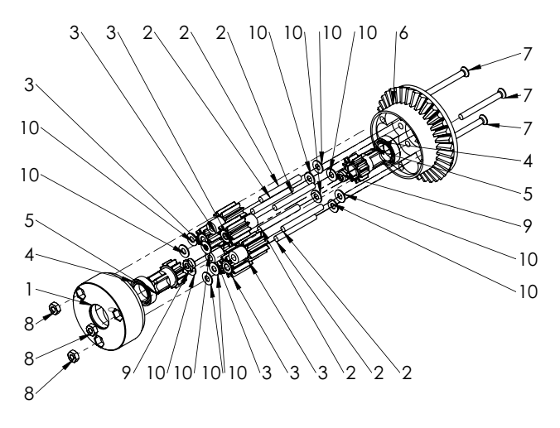

|  |  |  |  |
| --- | --- | --- | --- |
| ITEM NO. | PART | SPECIFICATION | QTY. |
| 1 | dıfferentıal-housıng-a |  | 1 |
| 2 | planet-gear-pın | Φ3mm x 28mm | 6 |
| 3 | planet-gear |  | 6 |
| 4 | 6700 - 15x10x4 bearıng |  | 2 |
| 5 | shaft-gear |  | 2 |
| 6 | dıfferentıal-housıng-b |  | 1 |
| 7 | countersunk flat head cross recess screw_ıso | M3 X 30 | 3 |
| 8 | hex nut style 1 gradeab_ıso | M3 | 3 |
| 9 | torque nut 08_ıso | M3 | 2 |
| 10 | plaın washer normal grade a_ıso | 3 | 12 |

Note:

Fill the housing with NLGI00 grade grease.

## DIFFERENTIAL ASSY

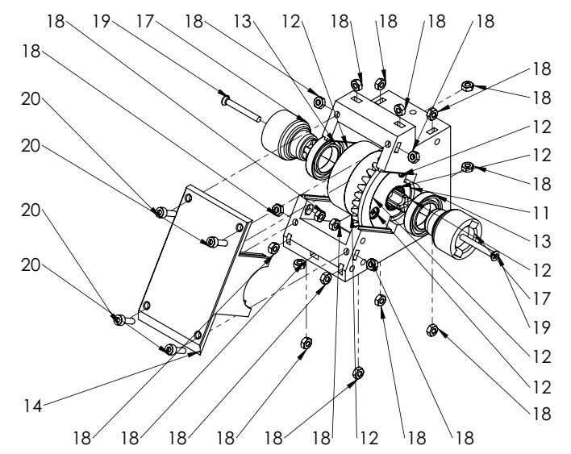

|  |  |  |  |
| --- | --- | --- | --- |
| ITEM NO. | PART | SPECIFICATION | QTY. |
| 11 | differential-box |  | 1 |
| 12 | differential-inner-assy |  | 1 |
| 13 | radial ball bearing_68_iso | 15X24X5MM 6802 | 2 |
| 14 | differential-box-lid |  | 1 |
| 15 | 6700 - 15x10x4 Bearing |  | 1 |
| 16 | drive-pinion-gear |  | 1 |
| 17 | wheel-shaft-housing |  | 2 |
| 18 | hex nut style 1 gradeab_iso | M3 | 21 |
| 19 | countersunk flat head cross recess screw_iso | M3 X 25 | 2 |
| 20 | socket head cap screw_iso | M3 X 10 | 4 |

Note:

Apply NLGI00 grade grease on the bevel gears.

## SHOCK ASSY

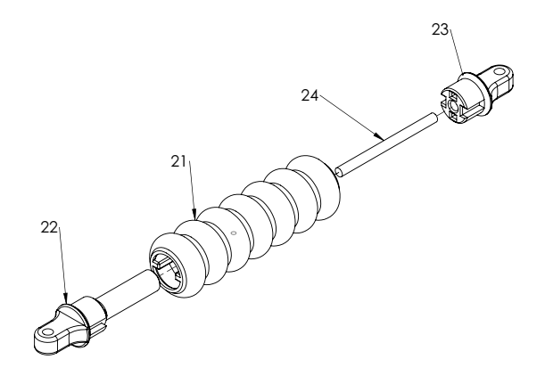

|  |  |  |  |
| --- | --- | --- | --- |
| ITEM NO. | PART | SPECIFICATION | QTY. |
| 21 | tpu-spring |  | 1 |
| 22 | shock-eye | B | 1 |
| 23 | shock-eye | A | 1 |
| 24 | shock-pin | Φ3mm x 40mm | 1 |

Note:

Glue the parts. Pin to shock-eye-A. Shock eyes to tpu-spring.

## WHEEL ASSY

|  |  |  |  |
| --- | --- | --- | --- |
| ITEM NO. | PART | SPECIFICATION | QTY. |
| 25 | rim |  | 1 |
| 26 | tire |  | 1 |

Notes:

Rim and tire fit very tightly and it requires a lot of force to assemble them together. You may try stepping on the sides of the tire to slide them onto the rim.

## WHEEL SHAFT ASSY

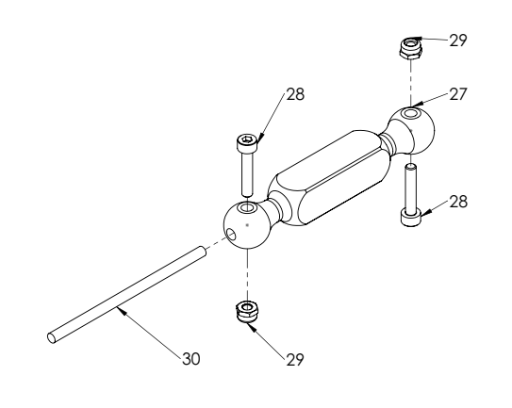

|  |  |  |  |
| --- | --- | --- | --- |
| ITEM NO. | PART | SPECIFICATION | QTY. |
| 27 | wheel-shaft |  | 1 |
| 28 | socket head cap screw_iso | M3 X 16 | 2 |
| 29 | torque nut 08_iso | M3 | 2 |
| 30 | wheel-shaft-strength-bar | Φ3mm x 60mm | 1 |

## FRONT ASSY

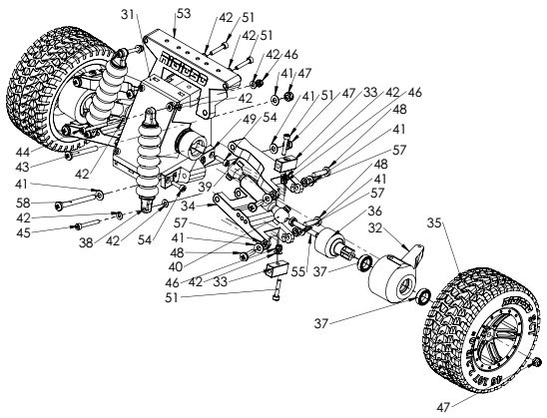

Notes:

* Only one side is exploded for constraining the sketch size.
* For ease of work, assemble the tires in the last step. Do not install them at this stage of the assembly.

|  |  |  |  |
| --- | --- | --- | --- |
| ITEM NO. | PART | SPECIFICATION | QTY. |
| 31 | differential-assy |  | 1 |
| 32 | steering-knuckle-left |  | 1 |
| 33 | steering-knuckle-bracket |  | 4 |
| 34 | control-arm-lower-FRONT | FRONT | 2 |
| 35 | wheel-assy |  | 2 |
| 36 | axle |  | 2 |
| 37 | 6700 - 15x10x4 Bearing |  | 4 |
| 38 | shock-assy-V2 |  | 2 |
| 39 | control-arm-upper-FRONT | FRONT | 2 |
| 40 | wheel-shaft-assy |  | 2 |
| 41 | plain washer normal grade a_iso | 4 | 13 |
| 42 | plain washer normal grade a_iso | 3 | 17 |
| 43 | pan head cross recess screw_iso | M4 X 35 | 2 |
| 44 | socket head cap screw_iso | M3 X 30 | 2 |
| 45 | socket head cap screw_iso | M3 X 25 | 2 |
| 46 | torque nut 08_iso | M3 | 6 |
| 47 | torque nut 08_iso | M4 | 6 |
| 48 | pan head cross recess screw_iso | M4 X 16 | 8 |
| 49 | control-arm-lower-bracket-front-left |  | 1 |
| 50 | control-arm-lower-bracket-front-right |  | 1 |
| 51 | socket head cap screw_iso | M3 X 16 | 6 |
| 52 | hex nut style 1 gradeab_iso | M3 | 2 |
| 53 | shock-tower-front |  | 1 |
| 54 | socket head cap screw_iso | M3 X 12 | 4 |
| 55 | hex screw gradeab_iso | M4 X 30 | 2 |
| 56 | steering-knuckle-right |  | 1 |
| 57 | hex nut style 1 gradeab_iso | M4 | 8 |
| 58 | pan head cross recess screw_iso_2 | M4 X 45 | 2 |

## BACK ASSY

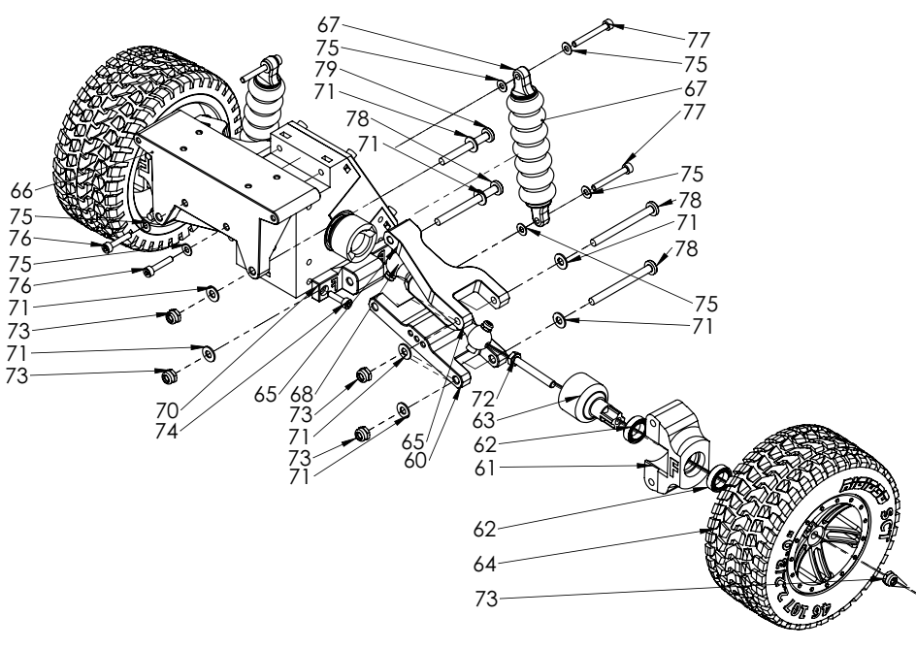

Notes:

* Only one side is exploded for constraining the sketch size.
* For ease of work, assemble the tires in the last step. Do not install them at this stage of the assembly.

|  |  |  |  |
| --- | --- | --- | --- |
| ITEM NO. | PART | SPECIFICATION | QTY. |
| 59 | differential-assy |  | 1 |
| 60 | control-arm-lower-BACK | BACK | 2 |
| 61 | knuckle-rear |  | 2 |
| 62 | 6700 - 15x10x4 Bearing |  | 4 |
| 63 | axle |  | 2 |
| 64 | wheel-assy |  | 2 |
| 65 | control-arm-upper-BACK | BACK | 2 |
| 66 | shock-tower-back |  | 1 |
| 67 | shock-assy-V2 |  | 2 |
| 68 | wheel-shaft-assy |  | 2 |
| 69 | control-arm-lower-bracket-back-right |  | 1 |
| 70 | control-arm-lower-bracket-back-left |  | 1 |
| 71 | plain washer normal grade a_iso | 4 | 16 |
| 72 | hex screw gradeab_iso | M4 X 30 | 2 |
| 73 | torque nut 08_iso | M4 | 10 |
| 74 | socket head cap screw_iso | M3 X 12 | 4 |
| 75 | plain washer normal grade a_iso | 3 | 10 |
| 76 | socket head cap screw_iso | M3 X 16 | 2 |
| 77 | socket head cap screw_iso | M3 X 25 | 4 |
| 78 | pan head cross recess screw_iso_2 | M4 X 45 | 6 |
| 79 | pan head cross recess screw_iso_2 | M4 X 35 | 2 |

## GEAR BOX ASSY

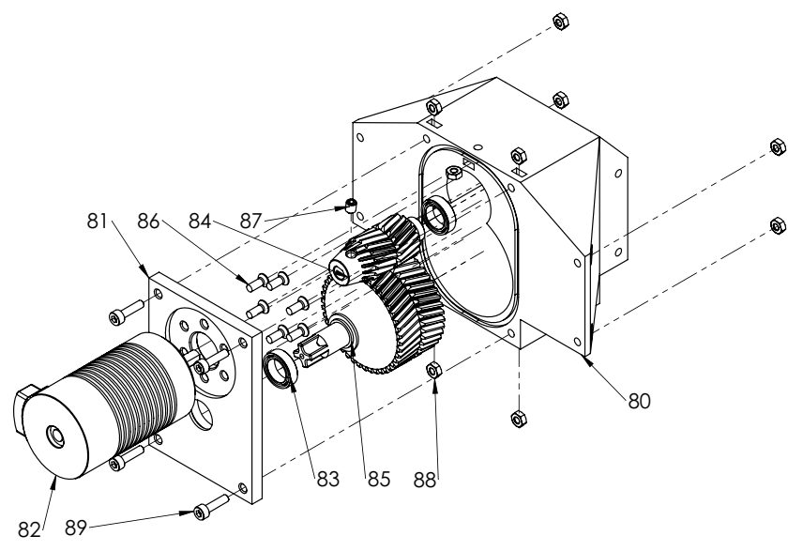

|  |  |  |  |
| --- | --- | --- | --- |
| ITEM NO. | PART | SPECIFICATION | QTY. |
| 80 | gear-box |  | 1 |
| 81 | gear-box-lid |  | 1 |
| 82 | motor |  | 1 |
| 83 | 6700 - 15x10x4 Bearing |  | 2 |
| 84 | sg-16-1 | 16T-M1 | 1 |
| 85 | sg-42-1 | 42T-M1 | 1 |
| 86 | countersunk flat head cross recess screw_iso | M3 X 8 | 6 |
| 87 | socket set screw cup point_iso | M4 X 5 | 1 |
| 88 | hex nut style 1 gradeab_iso | M3 | 9 |
| 89 | socket head cap screw_iso | M3 X 12 | 4 |

Note:

Apply NLGI00 grade grease on the gears.

## DRIVE SHAFT ASSY

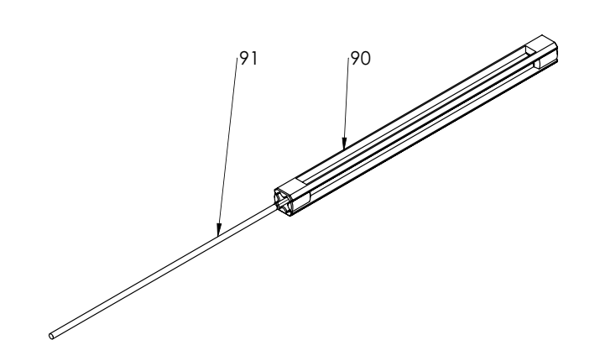

|  |  |  |  |
| --- | --- | --- | --- |
| ITEM NO. | PART | SPECIFICATION | QTY. |
| 90 | drive-shaft |  | 1 |
| 91 | drive-shaft-strength-bar | Φ3mm x 160mm | 1 |

## RIGID3D SCT BACK ASSY

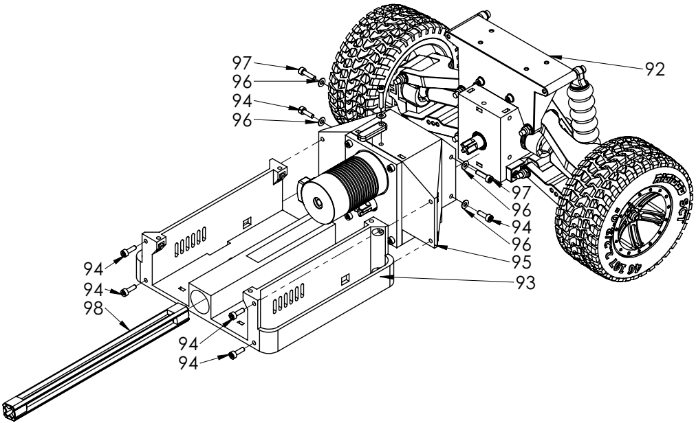

|  |  |  |  |
| --- | --- | --- | --- |
| ITEM NO. | PART | SPECIFICATION | QTY. |
| 92 | back-assy |  | 1 |
| 93 | chassis-middle |  | 1 |
| 94 | socket head cap screw_iso | M3 X 10 | 6 |
| 95 | gear-box-assy |  | 1 |
| 96 | plain washer normal grade a_iso | 3 | 5 |
| 97 | socket head cap screw_iso | M3 X 12 | 2 |
| 98 | drive-shaft-assy |  | 1 |
| 99 | socket head cap screw_iso | M3 X 16 | 1 |
| 100 | lock-bar |  | 1 |

## RIGID3D SCT Front ASSY

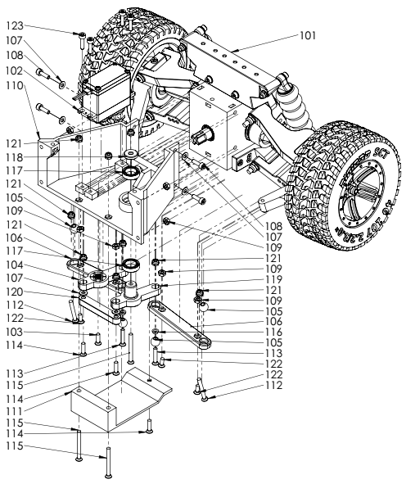

|  |  |  |  |
| --- | --- | --- | --- |
| ITEM NO. | PART | SPECIFICATION | QTY. |
| 101 | front-assy |  | 1 |
| 102 | servo |  | 1 |
| 103 | countersunk flat head cross recess screw_iso | M3 X 10 | 1 |
| 104 | servo-saver |  | 1 |
| 105 | rod-ball |  | 4 |
| 106 | steering-linkage |  | 2 |
| 107 | plain washer normal grade a_iso | 3 | 6 |
| 108 | socket head cap screw_iso | M3 X 10 | 4 |
| 109 | hex nut style 1 gradeab_iso | M3 | 8 |
| 110 | chassis-front |  | 1 |
| 111 | servo-cover |  | 1 |
| 112 | countersunk flat head cross recess screw_iso | M3 X 25 | 2 |
| 113 | countersunk flat head cross recess screw_iso | M3 X 16 | 2 |
| 114 | countersunk flat head cross recess screw_iso | M3 X 12 | 3 |
| 115 | countersunk flat head cross recess screw_iso | M3 X 30 | 3 |
| 116 | rod-ball-spacer |  | 2 |
| 117 | 6700 - 15x10x4 Bearing |  | 2 |
| 118 | servo-saver-washer |  | 1 |
| 119 | servo-saver-SLAVE | SLAVE | 1 |
| 120 | steering-center-link |  | 1 |
| 121 | torque nut 08_iso | M3 | 13 |
| 122 | countersunk flat head cross recess screw_iso | M3 X 8 | 4 |
| 123 | socket head cap screw_iso | M3 X 12 | 4 |

## RIGID3D SCT V2

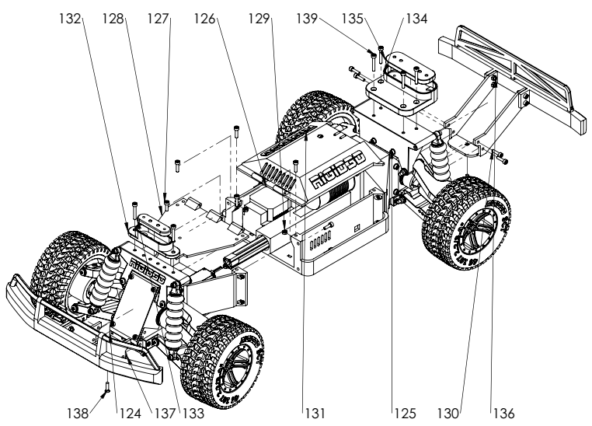

|  |  |  |  |
| --- | --- | --- | --- |
| ITEM NO. | PART | SPECIFICATION | QTY. |
| 124 | rigid3d-sct-front-assy |  | 1 |
| 125 | rigid3d-sct-back-assy |  | 1 |
| 126 | esc |  | 1 |
| 127 | socket head cap screw_iso | M3 X 10 | 5 |
| 128 | cover-front |  | 1 |
| 129 | hex nut style 1 gradeab_iso | M3 | 6 |
| 130 | socket head cap screw_iso | M3 X 12 | 12 |
| 131 | cover-middle |  | 1 |
| 132 | body-mount-front |  | 1 |
| 133 | body-mount-front-body-bracket |  | 1 |
| 134 | body-mount-rear |  | 1 |
| 135 | body-mount-rear-body-bracket |  | 1 |
| 136 | bumper-back |  | 1 |
| 137 | bumper-front |  | 1 |
| 138 | countersunk flat head cross recess screw_iso | M3 X 12 | 2 |
| 139 | socket head cap screw_iso | M3 X 20 | 6 |

Note:

Middle cover is hinged. Use a piece of 1.75mm filament as hinge pin.

## BUMPER FRONT

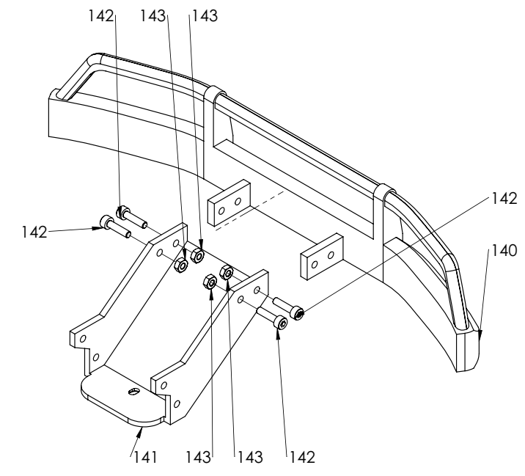

|  |  |  |  |
| --- | --- | --- | --- |
| ITEM NO. | PART | SPECIFICATION | QTY. |
| 140 | bumper-bottom-front |  | 1 |
| 141 | bumper-bracket-front |  | 1 |
| 142 | socket head cap screw_iso | M3 X 12 | 4 |
| 143 | hex nut style 1 gradeab_iso | M3 | 4 |

## BUMPER BACK

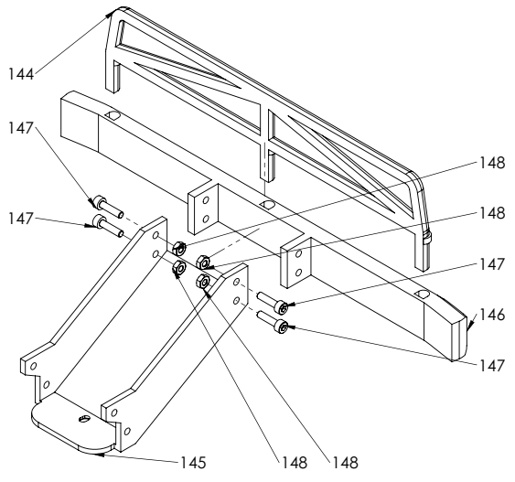

|  |  |  |  |
| --- | --- | --- | --- |
| ITEM NO. | PART | SPECIFICATION | QTY. |
| 144 | bumper-rail-back |  | 1 |
| 145 | bumper-bracket-back |  | 1 |
| 146 | bumper-bottom-back |  | 1 |
| 147 | socket head cap screw_iso | M3 X 12 | 4 |
| 148 | hex nut style 1 gradeab_iso | M3 | 4 |